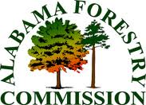
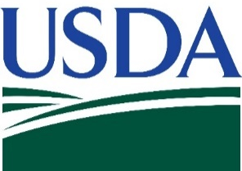
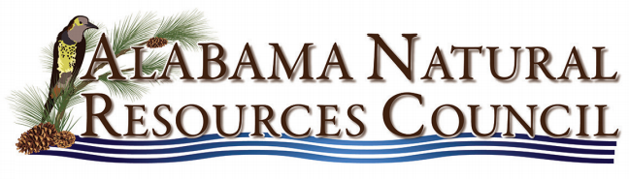

Getting the Most from Your Forestland
An Income Producing Workshop for Landowners
July 24, 2019

Scottsboro VFW Post
1616 Jefferson Drive
Scottsboro, AL 35768

• 9:00a: Welcoming Address
Norm Haley – Alabama Extension, Regional Extension Agent: Natural Resources
Greg Pate – Four W Forestry Group
Themika Sims – Alabama Extension, Jackson County Extension Coordinator
Lynn Washington- Alabama Forestry Commission, Work Unit Manager

• 9:10a: Alabama’s Forest and Economic Development
Gary Faulkner – Alabama Forestry Commission, Economic Development Specialist

• 10:00a: Alabama Timber Markets – What Do I Need to Know?
Dr. Adam Maggard - Alabama Extension, Forestry Specialist

• 10:30a: Non-Timber Income Production from Your Forestland
Dr. Adam Maggard - Alabama Extension, Forestry Specialist

• 11:15a: Investing in a Consulting Forester – What is it Worth to Me?
Local Timber Product Markets
Billy Rye – Forest Management Specialists, Inc., Owner, Consulting Forester

• 12:00p: Lunch

• 12:30p: Financial Assistance to Help Complete Forestry & Wildlife Activities
Shawn Manning – USDA-NRCS District, Conservationist

• 1:00p – 2:00p: Field Demonstration - Woodmizer Portable Sawmill
Dr. Adam Maggard - Alabama Extension, Forestry Specialist

• 2:00p: Evaluations & Adjourn

Special Thanks To Billy Rye (256-765-0397) of:
